3YR PROGRAMME AT A GLANCE

YR1 TERM 1 (Sep - Dec) 2014, 2017, 2020

CREATIVE CHALLENGE
- Artist
- Craft
- Entertainer
- Model Maker
- Photographer
- Writer
Nights Away – Colditz

YR1 TERM 2 (Jan - Feb) 2015, 2018, 2021

CREATIVE CHALLENGE
- Artist
- Craft
- Entertainer
- Model Maker
- Photographer
- Writer
Nights Away – Colditz

YR1 TERM 2 (Feb - Easter) 2015, 2018, 2021

EXPEDITION CHALLENGE
- Air and Sea Navigation
- Cyclist
- Geocaching
- Hill Walker
- Orienteer
Nights Away – District Skills (2015)
Cattaro (2018)
District Skills (2021)

YR1 TERM 3 (Easter - July) 2015, 2018, 2021

EXPEDITION CHALLENGE
- Air and Sea Navigation
- Cyclist
- Geocaching
- Hill Walker
- Orienteer
Nights Away – District Skills (2015)
Cattaro (2018)
District Skills (2021)

YR2 TERM 1 (Sep - Dec) 2015, 2018, 2021

WORLD CHALLENGE
- Astronautics
- Astronomer
- Communicator
- Environmental Conservation
- Fire Safety
- Forester
- Fundraising
- International
- Lifesaver
- Local Knowledge
- My Faith
- Naturalist
- Smallholder
- World Faiths
- World Issues
Nights Away – Colditz

YR2 TERM 2 (Jan - Feb) 2016, 2019, 2022

WORLD CHALLENGE
- Astronautics
- Astronomer
- Communicator
- Environmental Conservation
- Fire Safety
- Forester
- Fundraising
- International
- Lifesaver
- Local Knowledge
- My Faith
- Naturalist
- Smallholder
- World Faiths
- World Issues
Nights Away – Colditz

YR2 TERM 2 (Feb - Easter) 2016, 2019, 2022

ADVENTURE CHALLENGE
- Caver
- Climber
- Dragon Boating
- Equestrian
- Master at Arms
- Parascending
- Power Coxswain
- Pulling
- Snowsports
- Water Activities
Nights Away – Cattaro (2016)
District Skills (2019)
Cattaro (2022)

YR2 TERM 3 (Easter - July) 2016, 2019, 2022

ADVENTURE CHALLENGE
- Caver
- Climber
- Dragon Boating
- Equestrian
- Master at Arms
- Parascending
- Power Coxswain
- Pulling
- Snowsports
- Water Activities
Nights Away – Cattaro (2016)
District Skills (2019)
Cattaro (2022)

YR3 TERM 1 (Sep - Dec) 2016, 2019, 2022

SKILLS CHALLENGE
- Air Researcher
- Air Spotter
- Angler
- Athletics
- Athletics Plus
- Circus Skills
- DIY
- Electronics
- Hobbies
- Librarian
- Martial Arts
- Mechanic
- Media Relations and Marketing
- Physical Recreation
- Sports Enthusiast
- Street Sports
Nights Away – Colditz

YR3 TERM 2 (Jan - Feb) 2017, 2020, 2023

SKILLS CHALLENGE
- Air Researcher
- Air Spotter
- Angler
- Athletics
- Athletics Plus
- Circus Skills
- DIY
- Electronics
- Hobbies
- Librarian
- Martial Arts
- Mechanic
- Media Relations and Marketing
- Physical Recreation
- Sports Enthusiast
- Street Sports
Nights Away – Colditz

YR3 TERM 2 (Feb - Easter) 2017, 2020, 2023

OUTDOOR CHALLENGE
- Activity Centre Service
- Camper
- Chef
- Meteorologist
- Pioneer
- Quartermaster
- Survival Skills

- Emergency Aid 3 Contact Heartstart

Nights Away – District Skills (2017)
Cattaro (2020)
District Skills (2023)

YR3 TERM 3 (Easter - July) 2017, 2020, 2023

OUTDOOR CHALLENGE
- Activity Centre Service
- Camper
- Chef
- Meteorologist
- Pioneer
- Quartermaster
- Survival Skills

- Emergency Aid 3 Contact Heartstart

Nights Away – District Skills (2017)
Cattaro (2020)
District Skills (2023)

Air Activities
Community
Digital Citizen
Digital Maker
Emergency Aid
Hikes
Musician
Nautical Skills
Navigator
Nighrs Away
Paddle Sports
Sailing
Swimmer
Time on the Water

Emergency Aid 3
Hikes (At home)
IT 3 (At home)
Musician 3 (At home)
Nights Away
Swimmer 3 (At home)

Activity Plus
Administrator
Advanced Aviation Skills
Advanced Nautical Skills
Aeronautics
Air Researcher
Air Spotter
Angler
Artist
Arts Enthusiast
Astronautics
Astronomer
Athletics
Athletics Plus
Aviation Skills
Basic Aviation Skills
Basic Nautical Skills
Camp Cook
Camper
Campsite Service
Caver
Chef
Circus Skills
Climber
Communicator
Craft
Cyclist
DIY
Dinghy Sailor
Dragon Boater
Electronics
Entertainer
Equestrian
Fire Safety
Forester
Global Conservation
Guide
Heritage
Hiker
Hill Walker
Hobbies (At home)
Instructor
Interpreter
Librarian
Lifesaver
Martial Arts
Master at Arms
Mechanic
Meteorologist
Model Maker
My Faith
Naturalist
Nautical Skills
Navigator
Orienteer
Paddlesports
Parascending
Photographer
Physical Recreation
Pioneer
Power Coxwain
Public Relations
Pulling
Quartermaster
Smallholder
Snowsports
Sports Enthusiast
Street Sports
Survival Skills
Watersports
World Faiths
Writer

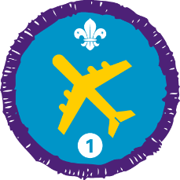  Air Activities Staged Activity Badge | 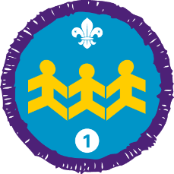  Community Impact Staged Activity Badge | 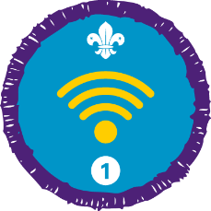  Digital Citizen Staged Activity Badge
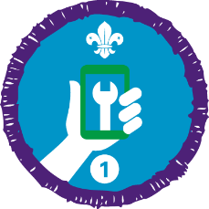  Digital Maker Staged Activity Badge | 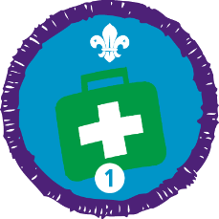  Emergency Aid Staged Activity Badge | 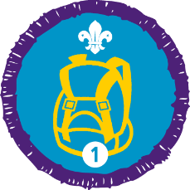  Hikes Away Staged Activity Badge
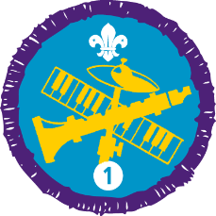  Musician Staged Activity Badge | Nautical Skills Staged Activity Badge | 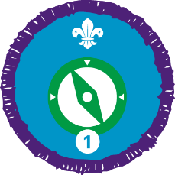  Navigator Staged Activity Badge
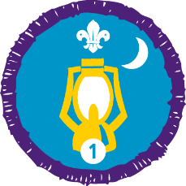  Nights Away Staged Activity Badge | 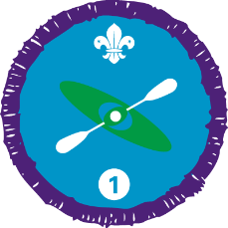  Paddle Sports Staged Activity Badge | 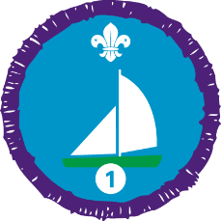  Sailing Staged Activity Badge
Swimmer Staged Activity Badge | 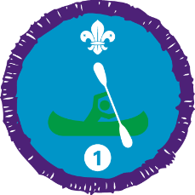  Time on the Water Staged Activity Badge

